Fuzzy Logic

**abstract -** ***This scientific paper will be focused on explained how to use a Fuzzy Logic script written on Python to solve a air conditioner system***

**1. INTRODUCTION**

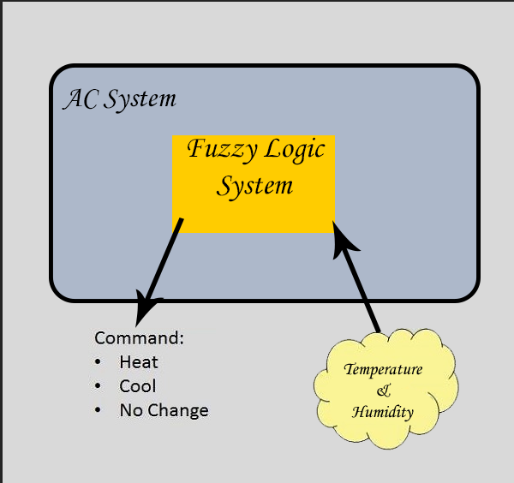

The function of the script is to provide a command output from 2 options input that are humidity and temperature,

The output will depend on a set of rules to pick if it has to warm up or cool the room, the rules are a set of temperature states:

|  |  |  |  |  |
| --- | --- | --- | --- | --- |
| Hottest | Hot | Warm | Cold | Coldest |

As well as a set of humidity values:

|  |  |  |
| --- | --- | --- |
| Low | Optimal | High |

Temperature crisp values can go from 0-40 degrees

and humidity can go from 0-100. These values will be processed by the desired formula, in the case of the temperature, will need a trapezoidal function to convert the crisps values into values that the AI can use, this is called Fuzzify.

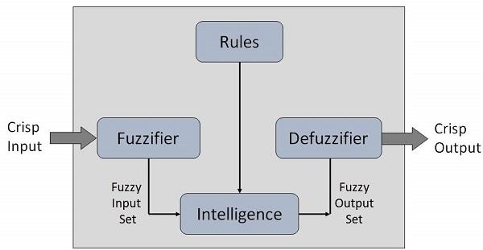

**2. DEFINITION**

According to Wikipedia, it is based on the observation that people make decisions based on imprecise and non-numerical information, fuzzy models or sets are mathematical means of representing vagueness and imprecise information, hence the term fuzzy. These models have the capability of recognising, representing, manipulating, interpreting, and utilising data and information that are vague and lack certainty.

**3. CONCLUSION**

The fuzzy logic can improve a lot the way we program machines to make decision and help us doing tasks while taking the right actions, it takes a crisp input, and it fuzzifiesthe input in order to work with it, then it applies the given rules for making the decision, and finally it deffuzifies the result to give a clean and crisp output, friendly to the user, what makes it easier to understand.

**4. TEST**

Values taken for test are:

Temperature: 30

Humidity: 100

Outputs are:

Command is defined between 15 y 25

17.333333333333336

**5. BIBLIOGRAPHY**

1. <https://pythonhosted.org/scikit-fuzzy/auto_examples/plot_tipping_problem_newapi.html>
2. <https://pypi.org/project/scikit-fuzzy/>
3. <https://www.tutorialspoint.com/artificial_intelligence/artificial_intelligence_fuzzy_logic_systems.htm>

